9 September 2022

Mr Romlie Mokak
Commissioner
Productivity Commission
4 National Circuit Canberra
ACT 2600

By email: indigenous.arts@pc.gov.au

Dear Commissioner,

RE: Submission in response to the Aboriginal and Torres Strait Islander Visual Arts and Crafts Draft Report

The Australian Libraries and Archives Copyright Coalition (ALACC) and the Australian Digital Alliance (ADA) welcome the opportunity to respond to the Aboriginal and Torres Strait Islander Visual Arts and Craft Draft Report. Both organisations recognise the importance of Indigenous Cultural and Intellectual Property (ICIP), especially as it relates to the sectors to which our members belong.
The ALACC is the main consultive body and policy forum for the discussion of copyright issues affecting Australian libraries and archives. The members of the ALACC support a copyright framework that appropriately protects the interests of rights holders while ensuring access to important cultural, educational, and historical content for the public’s benefit. More information about the ALACC is available at alacc.org.au/about.
The ADA provides a voice for the public interest in access to knowledge, information and culture in copyright reform debates. The ADA unites those who seek copyright laws that both provide reasonable incentives for creators and support the wider public interest in the advancement of learning, innovation and culture. More information about the ADA is available at digital.org.au/about.
The ALACC and the ADA acknowledge that we are not experts with respect to ICIP, however we acknowledge that this is an important issue that impacts upon our member organisations, in particular cultural institutions that hold extensive collections that are relevant to First-Nations communities.
In the sectors we represent there is a growing awareness of the importance of ICIP. Libraries and archives are increasing their engagement with Aboriginal and Torres Strait Islander communities in the collection, preservation, presentation and management of ICIP. We would ask the Commission to recognise that ICIP also exists in the documentary resources that cultural institutions collect and provide access to, and consider impacts of any decisions on libraries' and archives' ability to collect, preserve and appropriately provide access to these materials.
We support efforts across government to more effectively recognise and protect ICIP in Australia. ALACC and the ADA are supportive of a First Nations-led framework and support the Productivity Commission’s process of consulting broadly, particularly with Aboriginal and Torres Strait Islander peoples, communities and organisations. Further consultation could be undertaken collaboratively with AIATSIS and Indigenous Art Code. The upcoming Purrumpa: First Nations Arts & Culture National Gathering 2022 is a logical focal point for consultation with First Nations communities.
We also support nonlegal options such as Protocols, principles that relate to indigenous data sovereignty, and industry practices (e.g. The Tandanya Declaration, ATSILIRN Aboriginal and Torres Strait Islander Protocols for Libraries, Archives and Information Services, First Peoples: A Roadmap for Enhancing Indigenous Engagement in Museums and Galleries and others).

We are supportive of ICIP protection through a new specifically designed legal instrument that is First-Nations led, not just an amendment to existing legislation, such as the copyright act which could bring about unintended consequences. In particular, we note that any changes to the Copyright Act which reverse amendments relating to the duration of copyright protection for unpublished works will have catastrophic impacts. These hard-won changes came into effect in 2019, and brought copyright terms for unpublished works into line with other works, i.e. copyright expires 70 years after death. These changes made it possible for cultural institutions to provide online access to large parts of their historic collections, opening these collections to much broader audiences. Applying changes which are intended to protect ICIP in the Copyright Act would be a seriously retrograde step and inconsistent with objectives of the Berne Convention.
Additionally, we are supportive that legal instruments protecting ICIP are developed in harmony with the government’s implementation of The Uluru Statement from the Heart, and with reference to the principles in the United Nations Declaration on the Rights of Indigenous People (UNDRIP).
Our contact for inquiries related to this submission is Sarah Powell, who can be contacted at sarah@alacc.org.au or on 02 6262 1118.

Yours sincerely,


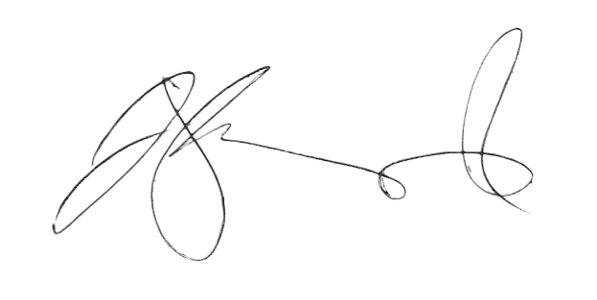

Justine Heazlewood Derek Whitehead
Chair Chair
Australian Libraries and Archives Australian Digital Alliance
Copyright Coalition

