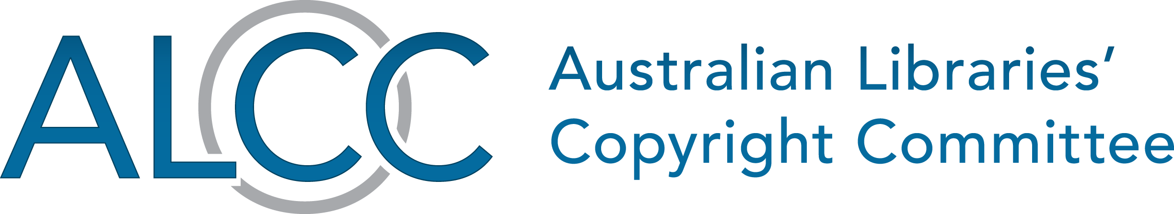

Libraries and archives welcome safe harbour extension
Wednesday 27 June 2018
For immediate release
Canberra, Australia—Australia’s libraries and archives will have the same legal protections as commercial ISPs when they provide online services to the public, thanks to copyright amendments passed today.
The Australian Libraries Copyright Committee (ALCC) welcomes the passing of the Copyright Amendment (Service Providers) Act 2018 and the increased certainty it affords the libraries and archives sector.
Australia’s copyright safe harbour scheme currently protects commercial ISPs from liability for their clients’ actions, but does not provide this protection to others delivering the same services. The Act extends the scheme to educational, disability and cultural institutions, including libraries and archives.
“For too long the caretakers of our cultural collections have been subjected to greater legal risk than they should have been,” said ALCC representative Jessica Coates.
“Educational, cultural and disability groups provide internet services to hundreds of thousands of people each year, and are the main point of access for the most vulnerable in our society. For more than a decade they have been calling for the same legal protections as commercial ISPs – the same protections their peers receive overseas. So they are very pleased that the amendments have finally been passed.”
“Bringing libraries and archives into the safe harbour scheme will give them greater confidence to take advantage of the latest technologies to provide high quality services to all Australians. It will also increase the efficiency and reduce the costs of battling online infringement, providing more tools for creators to have infringing materials taken down and more rights for Australian consumers if they are accused of copyright infringement.”
“This is an important new protection for Australia’s cultural institutions, and a big step towards ensuring Australia’s safe harbours are world standard and apply the same clear and simple rules to all organisations operating in the space” said Ms Coates.
As the primary policy body in Australia for the discussion of copyright issues affecting the library, archive and information sectors, the ALCC will be publishing guidelines on the safe harbour scheme and a self evaluation checklist for libraries and archives.

–ENDS–

Interviews and media contact
Ms Coates is available for interview by request. All media inquiries related to this media release should be directed to:
Ms Jessica Coates
Executive Officer
Australian Digital Alliance

0412 072 224
info@libcopyright.org.au

